GLOBAL AI OLYMPIAD COURSE
Generative AI & Large Language Models
Chapter 1 • Concept Pages • Worksheets • Activities • Puzzles
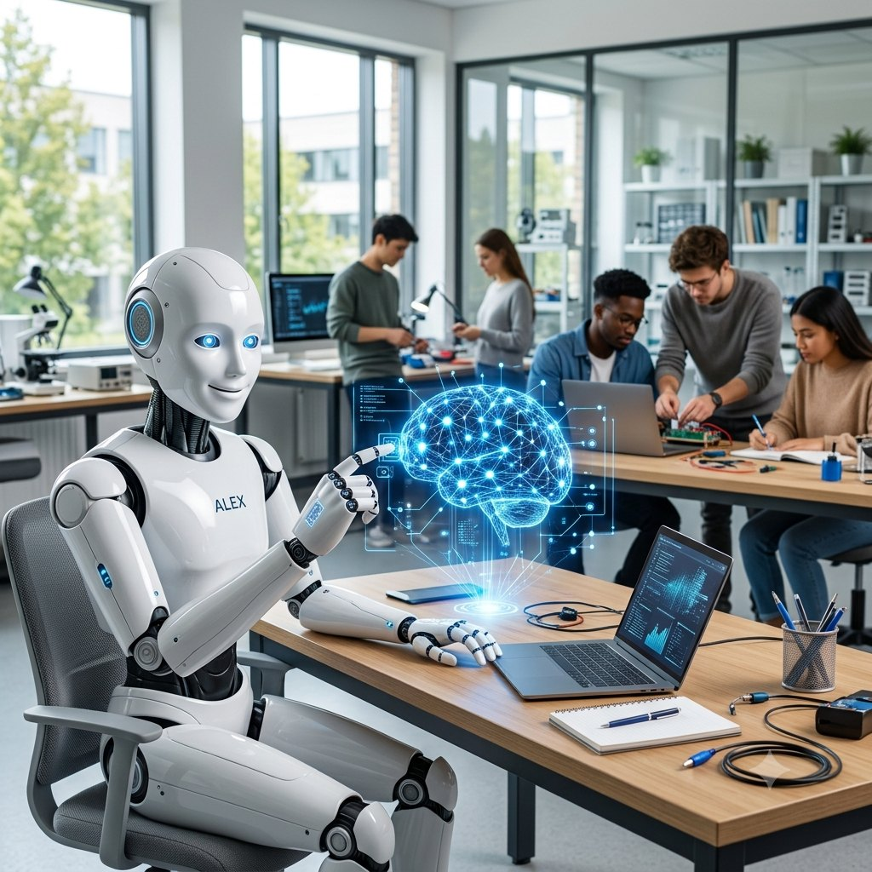
Undergraduate • Year 3 | Learn • Practise • Create
Name: ______________________________ Class: ______________ Roll No.: ______________

START HERE | Welcome, AI Explorer!

This book turns Chapter 1 of the Global AI Olympiad course into a hands-on adventure. Read each concept page, then solve the worksheet or activity that follows. Finish with the puzzle and the Olympiad quiz!
By the end of this chapter you will be able to…
- Explain what generative AI is and how it differs from discriminative AI.
- Describe the four families of generative models.
- Understand tokens, embeddings and self-attention in a Transformer.
- Explain how temperature changes the output of an LLM.
- Outline how an LLM is trained, and how prompting and RAG improve it.
- Spot the risks of AI and use it responsibly.

CONCEPT – read & learn | WORKSHEET – practise | ACTIVITY – do & create
PUZZLE – have fun | QUIZ – test yourself | ANSWERS – check
Contents
3 | Concept 1 | What Is Generative AI?
4 | Worksheet 1 | Discriminative or Generative?
5 | Concept 2 | A Brief History of Generative AI
6 | Activity 1 | Time-Travel Challenge
7 | Concept 3 | Families of Generative Models
8 | Worksheet 2 | Match the Model Family
9 | Concept 4 | Tokens and Embeddings
10 | Activity 2 | Be the Tokenizer
11 | Concept 5 | Self-Attention
12 | Worksheet 3 | Attention Detective
13 | Concept 6 | Next-Token Prediction and Temperature
14 | Activity 3 | Temperature Lab
15 | Concept 7 | How an LLM Is Built
16 | Worksheet 4 | Order the Pipeline
17 | Concept 8 | Prompting and RAG
18 | Activity 4 | Prompt Makeover
19 | Concept 9 | Risks and Responsible AI
20 | Worksheet 5 | Fact or Fib?
21 | Puzzle | AI Word Search
22 | Quiz | Olympiad Challenge Quiz
23 | Answers | Answer Key
Photographs in this book are AI-generated images created for teaching.

CONCEPT 1 | What Is Generative AI?


Generative AI creates NEW content, such as text, images, music, video and code, by learning patterns from huge amounts of data. It does not copy and paste: it samples from what it has learned.
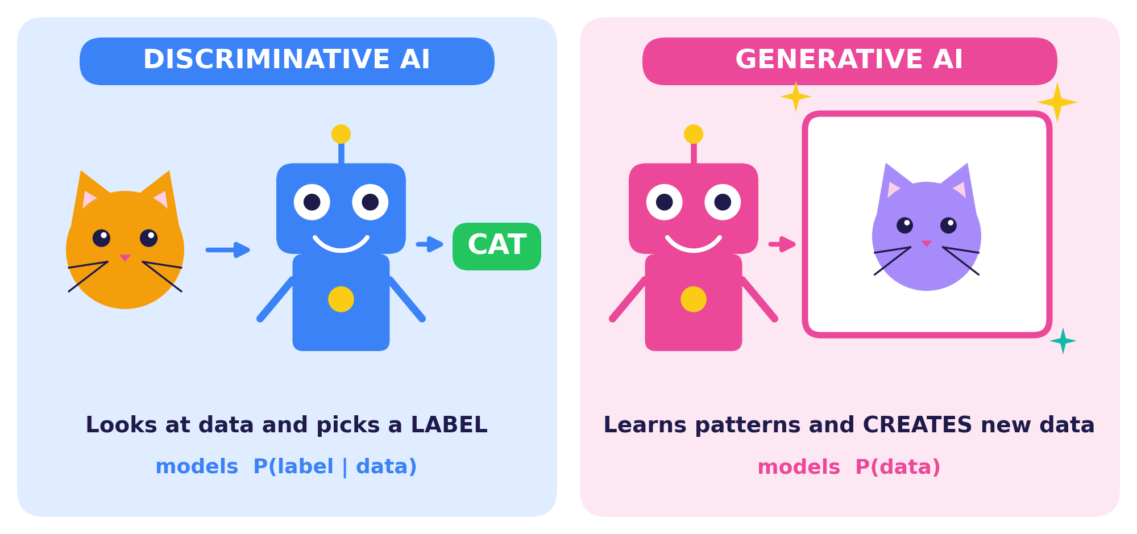
 | Discriminative AI | Generative AI
Asks | “What is this?” | “Can you make one like this?”
Learns | The boundary between classes | The distribution of the data itself
Output | A label or a number | New text, image, audio or code
Examples | Spam filter, face unlock, fraud alert | Chat assistants, AI art, code helpers

Remember
Generative models are not databases. They learn patterns, then create fresh outputs that fit those patterns.

Think!
Name one app you use every day. Is the AI inside it discriminative, generative, or both? Discuss with a partner.

WORKSHEET 1 | Discriminative or Generative?
Name: ____________________ Class: __________ Date: __________ Score: ______
TASK A Tick the correct type of AI for each job.
# | What the AI does | Discriminative | Generative
1 | An email spam detector | ☐ | ☐
2 | Writing a poem about rain | ☐ | ☐
3 | Finding tumours in X-ray images | ☐ | ☐
4 | Composing a new jazz tune | ☐ | ☐
5 | Predicting a house price from its features | ☐ | ☐
6 | Drawing a picture from a text description | ☐ | ☐
7 | Flagging fraud in bank transactions | ☐ | ☐
8 | Writing code from a plain-English request | ☐ | ☐
9 | Unlocking a phone with your face | ☐ | ☐
10 | Creating a talking avatar video | ☐ | ☐
TASK B Write one real example of each type that you have used or seen.
Discriminative example: _______________________________________________________________________
Generative example: ____________________________________________________________________
TASK C Sketch your own generative AI idea. What would it create? Draw it and label it.

CONCEPT 2 | A Brief History of Generative AI
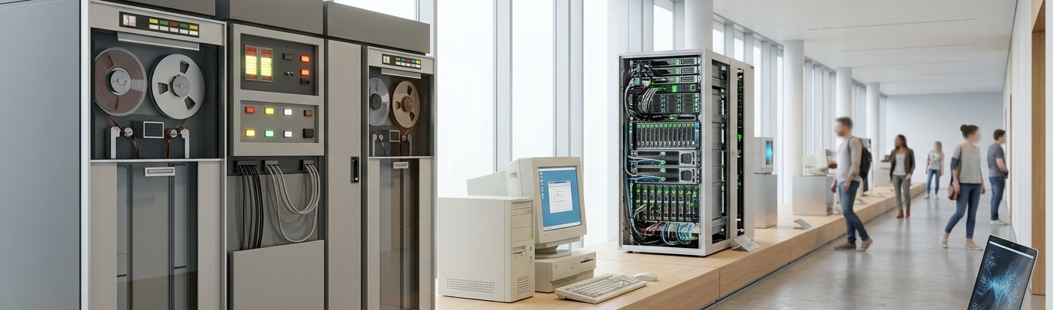

Generative models are decades old, but they exploded recently. Follow the milestones on the timeline below.
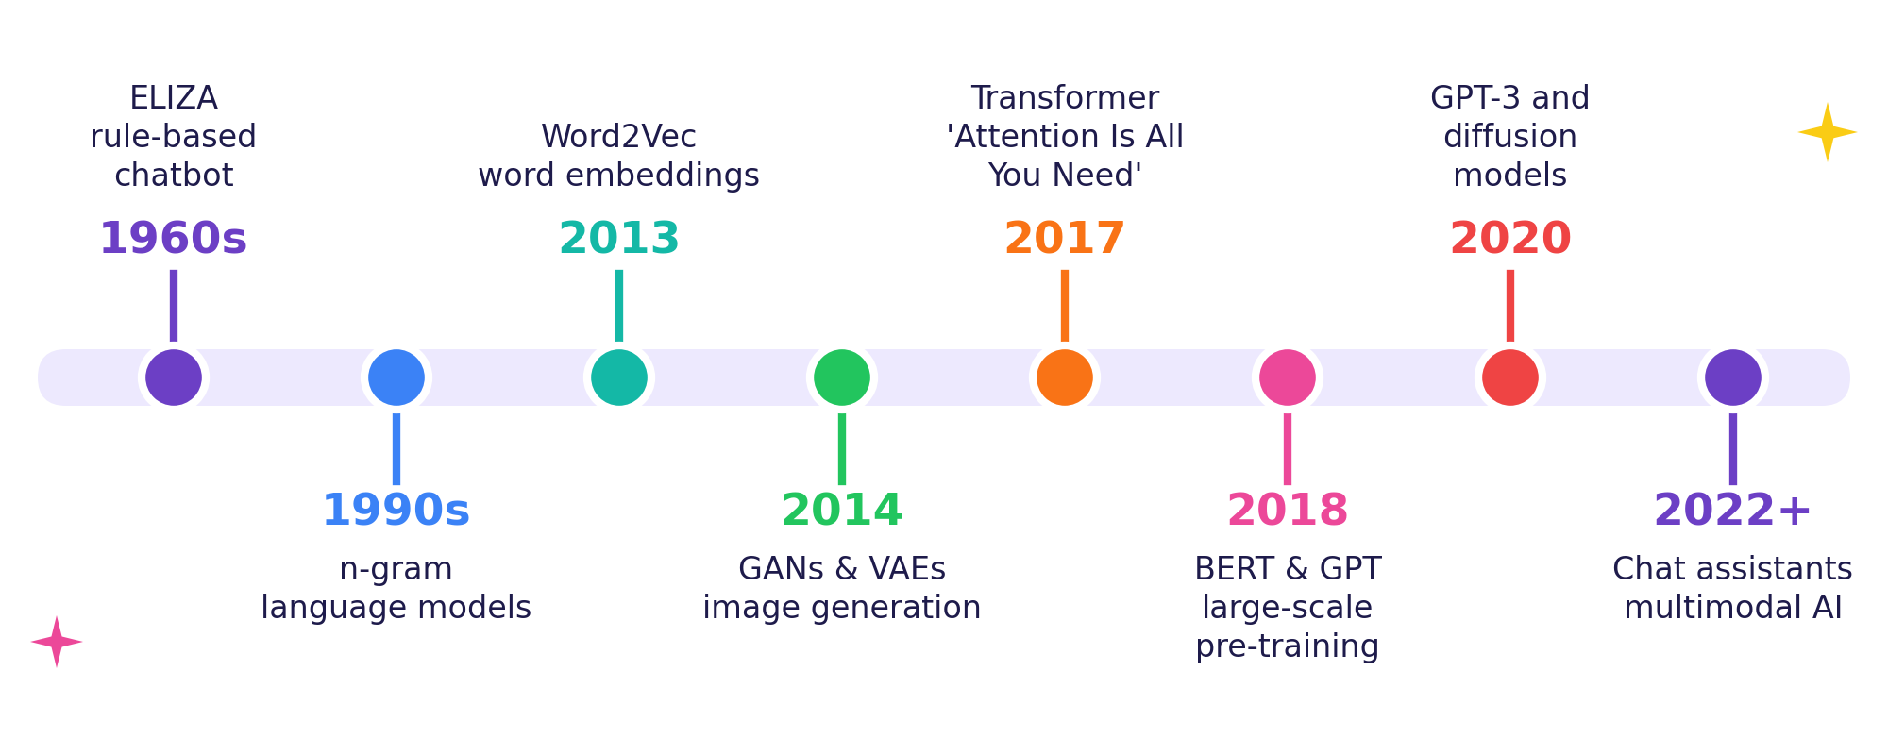
Why did it happen now?
1 Big Data | 2 Powerful Chips | 3 Transformers
The internet gave billions of text and image examples to learn from. | GPUs and TPUs can train huge neural networks with many calculations in parallel. | A new design that lets the model look at all words at once and learn how they relate.

Fun fact
GPT-3 (2020) has about 175 billion parameters. Parameters are the adjustable numbers a model learns during training. Think of them as billions of tiny dials.

Olympiad tip
Remember the year pair 2017 → Transformer and 2014 → GAN. They appear often in quiz questions.

ACTIVITY 1 | Time-Travel Challenge
Name: ____________________ Class: __________ Date: __________ Score: ______
TASK A Fill each blank using the word bank.
WORD BANK: Transformer • ELIZA • Word2Vec • GPT-3 • Goodfellow • Diffusion

1. In the 1960s, the chatbot ____________ used hand-written rules to imitate conversation.
2. ____________ (2013) turned words into vectors that capture meaning.
3. The ____________ architecture was introduced in 2017 in “Attention Is All You Need”.
4. ____________ had about 175 billion parameters and showed few-shot learning.
5. GANs were introduced by ____________ and colleagues in 2014.
6. ____________ models create images by removing noise step by step.
TASK B Put these five events in order, from oldest (1) to newest (5). Write the number in the box.
No. ___ | A. GPT-3 is released with 175 billion parameters
No. ___ | B. Word2Vec makes word embeddings popular
No. ___ | C. The Transformer architecture is published
No. ___ | D. ELIZA chats using rule-based patterns
No. ___ | E. Chat assistants reach millions of users
TASK C Future vision: What AI milestone do you predict by 2030? Write 2–3 lines.

CONCEPT 3 | Families of Generative Models
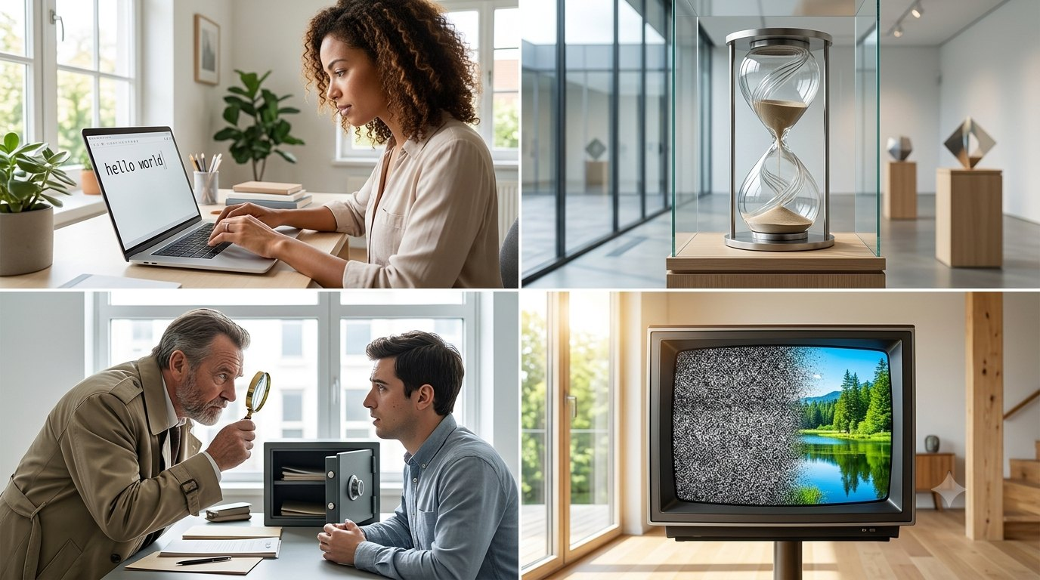

Different model families generate data in different ways. Each has strengths and trade-offs.
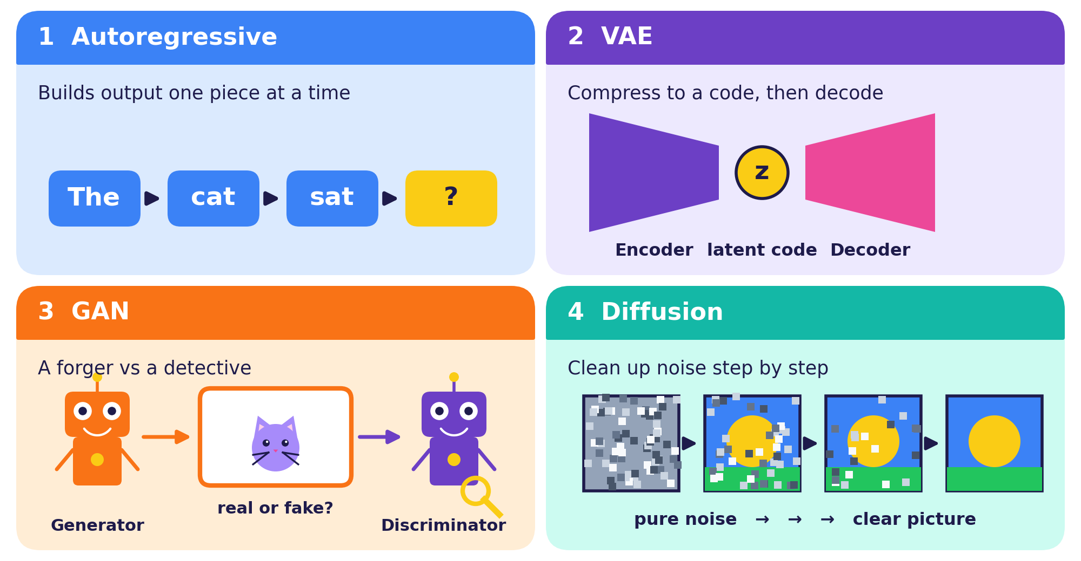
Family | How it generates | Strength | Watch out
Autoregressive | Predicts the next piece, then repeats | Excellent for language | One step at a time
VAE | Samples a latent code and decodes it | Stable training; smooth latent space | Outputs can be blurry
GAN | Generator tries to fool a discriminator | Sharp images, fast to sample | Hard to train; mode collapse
Diffusion | Removes noise step by step | High-quality, diverse images | Many steps can be slow

Key idea
GPT-style LLMs are autoregressive Transformers. Most modern text-to-image tools use diffusion models.

WORKSHEET 2 | Match the Model Family
Name: ____________________ Class: __________ Date: __________ Score: ______
TASK A Match each model family (1–4) with its description (A–D). Write the letter in the blank.
Model family | Letter | Description
1 Autoregressive | ____ | A. Two networks compete: a forger and a detective
2 VAE | ____ | B. Compresses data into a latent code, then decodes it
3 GAN | ____ | C. Starts from noise and removes it step by step
4 Diffusion | ____ | D. Generates one piece at a time using everything before it
TASK B Which model family would you choose? Write your choice and one reason.
Scenario | Your choice | Reason
a) A chatbot that writes essays
b) A text-to-image art app
c) Exploring smooth changes between two faces in a latent space
d) A fast generator of sharp, realistic images trained with a rival network
TASK C True or False? Circle T or F.
1. GANs have an encoder and a decoder as their two main parts. T / F
2. Diffusion models start from random noise. T / F
3. GPT-style language models are autoregressive. T / F
TASK D In your own words: why can GANs suffer from “mode collapse”?

CONCEPT 4 | Tokens and Embeddings
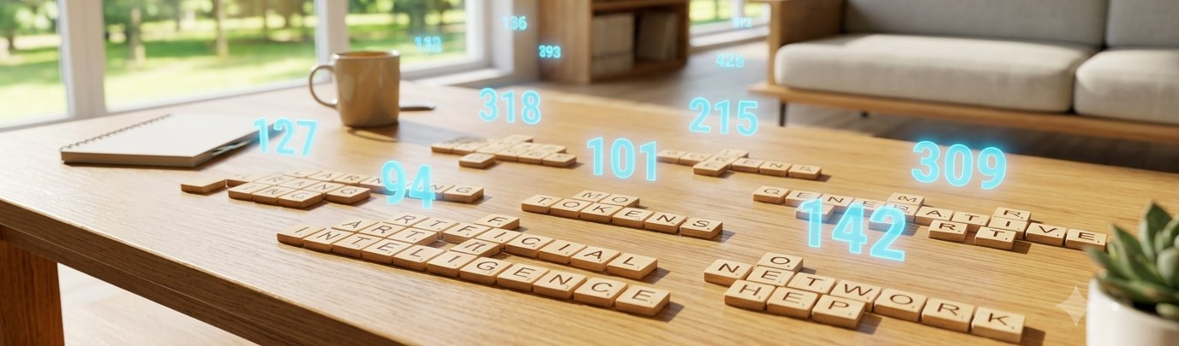

Computers work with numbers, not letters. Before an LLM can read your sentence, the text goes on a four-step journey into numbers.
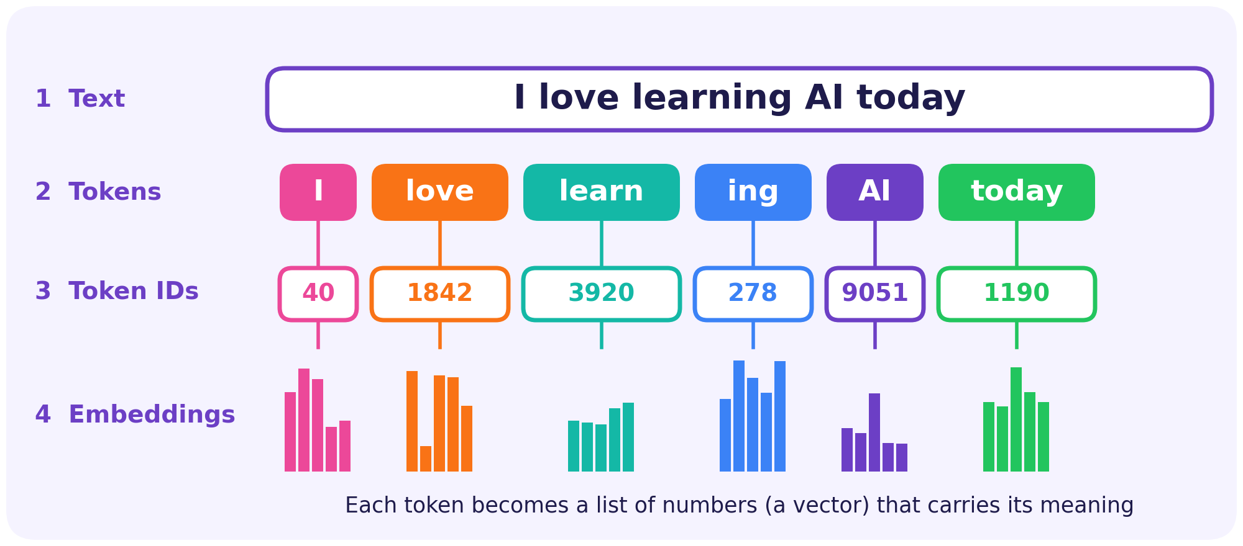
Token  A chunk of text the model treats as one unit: a word, part of a word, or a symbol. | Token ID  Each token has a unique whole number in the model’s vocabulary.
Embedding  A list of numbers (a vector) that captures a token’s meaning. Similar meanings sit close together. | Context window  The maximum number of tokens the model can look at in one go.

Try this
unbelievable → un | believ | able (3 tokens). Rare or long words are split into more pieces.
Rule of thumb: in English, 1 token is roughly ¾ of a word.

Why sub-words?
Sub-word tokens keep the vocabulary small, yet the model can still build any new word from familiar pieces.

ACTIVITY 2 | Be the Tokenizer
Name: ____________________ Class: __________ Date: __________ Score: ______
TASK A Split each word into sensible sub-word tokens. Write one piece per box and count them.
Word | Token 1 | Token 2 | Token 3 | Token 4 | Count
unbelievable (example) | un | believ | able |  | 3
unhappiness
playing
Generative
tokenization
AI-powered
TASK B Token maths. Use the rule: 1 token ≈ ¾ of a word.
a) A 4,000-token context window fits about how many words? __________
b) A 1,500-word essay is about how many tokens? __________
TASK C Embedding map: write these words on the grid so that similar meanings sit close together.
king • queen • apple • banana • car • truck

 | 1 | 2 | 3 | 4 | 5 | 6 | 7 | 8
8
7
6
5
4
3
2
1

Which two words did you place closest together, and why?

CONCEPT 5 | Self-Attention
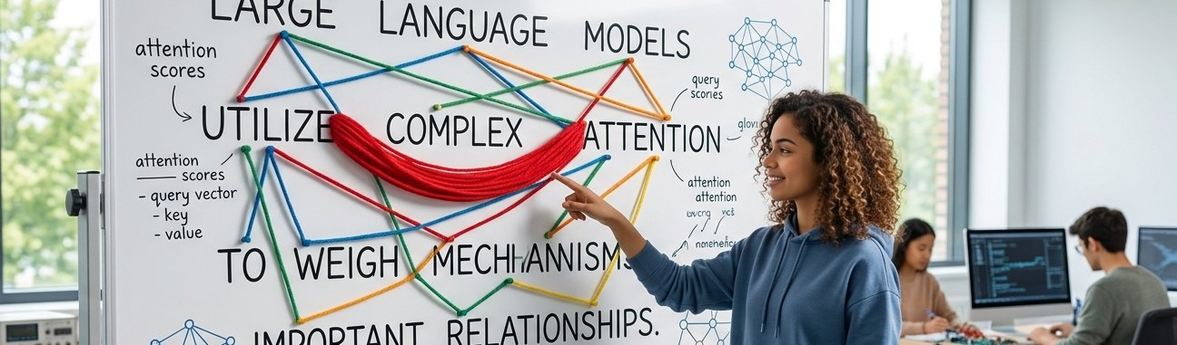

Self-attention lets every token look at all the other tokens and decide which ones matter most. It is the core idea of the Transformer.
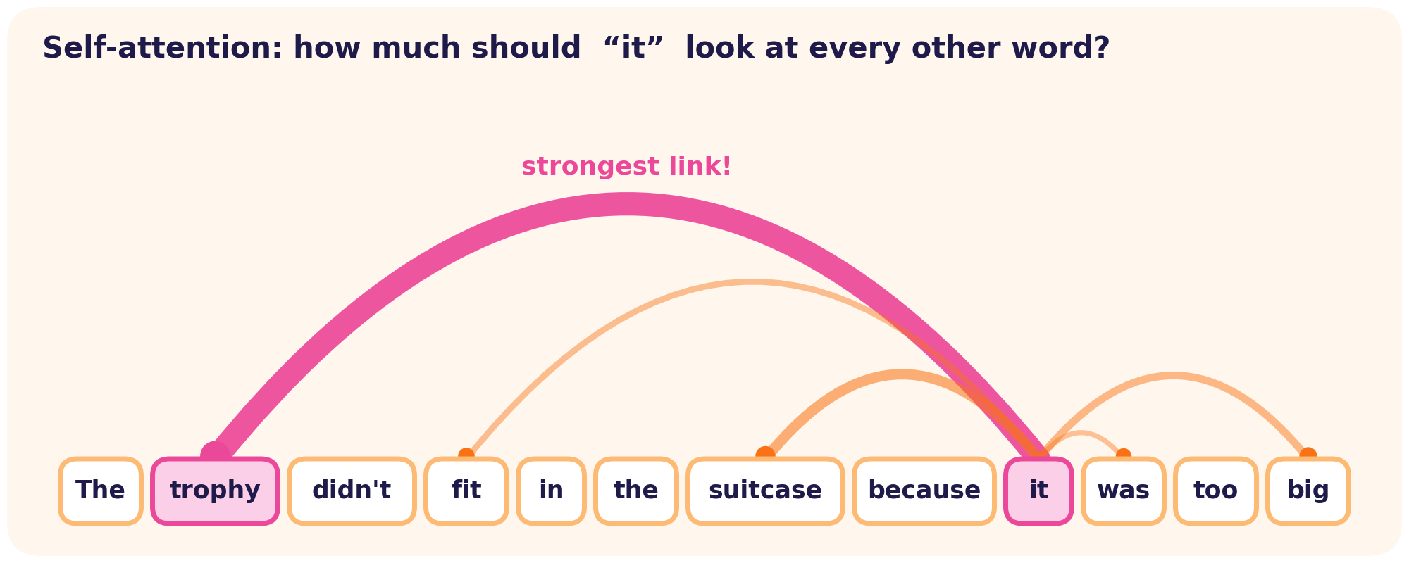
Think of it as searching a library
Query (Q) | Key (K) | Value (V)
“What am I looking for?” The question a token asks. | “What do I contain?” The label on each book. | “What information do I give?” The content inside the book.

The formula
Attention(Q, K, V) = softmax( Q · K^{T} / √d_{k} ) · V
Compare queries with keys to get scores, turn scores into weights with softmax, then take a weighted mix of the values.

Surprise!
Change “big” to “small” in the example sentence and “it” now points to the suitcase. Attention shifts with context. Many attention “heads” work in parallel, each tracking a different kind of relationship.

WORKSHEET 3 | Attention Detective
Name: ____________________ Class: __________ Date: __________ Score: ______
TASK A Circle the word that the underlined pronoun refers to, then write it in the blank.
1. The trophy didn’t fit in the suitcase because it was too big. → ________
2. The trophy didn’t fit in the suitcase because it was too small. → ________
3. The students thanked the professor because he explained the topic clearly. → ________
4. The laptop slipped off the table and it broke. → ________
TASK B Attention scores. Read: “The cat ate the fish because it was hungry.” How strongly should “it” attend to each word? Score 0 (ignore) to 5 (very strong), then shade the cell darker for higher scores.
The | cat | ate | the | fish | because | it | was | hungry
 |  |  |  |  |  | —
Row 1 = your score (0–5). Row 2 = shading.
TASK C Explain in 2–3 lines why self-attention helps a model decide what “it” refers to.
TASK D Bonus: Why do Transformers read all tokens in parallel instead of one at a time? Give one advantage.

CONCEPT 6 | Next-Token Prediction and Temperature


An LLM plays one game over and over: predict the next token. For “The sky is ___” it gives every word in its vocabulary a probability, for example blue 70%, clear 15%, grey 10%. A decoding rule then picks one.
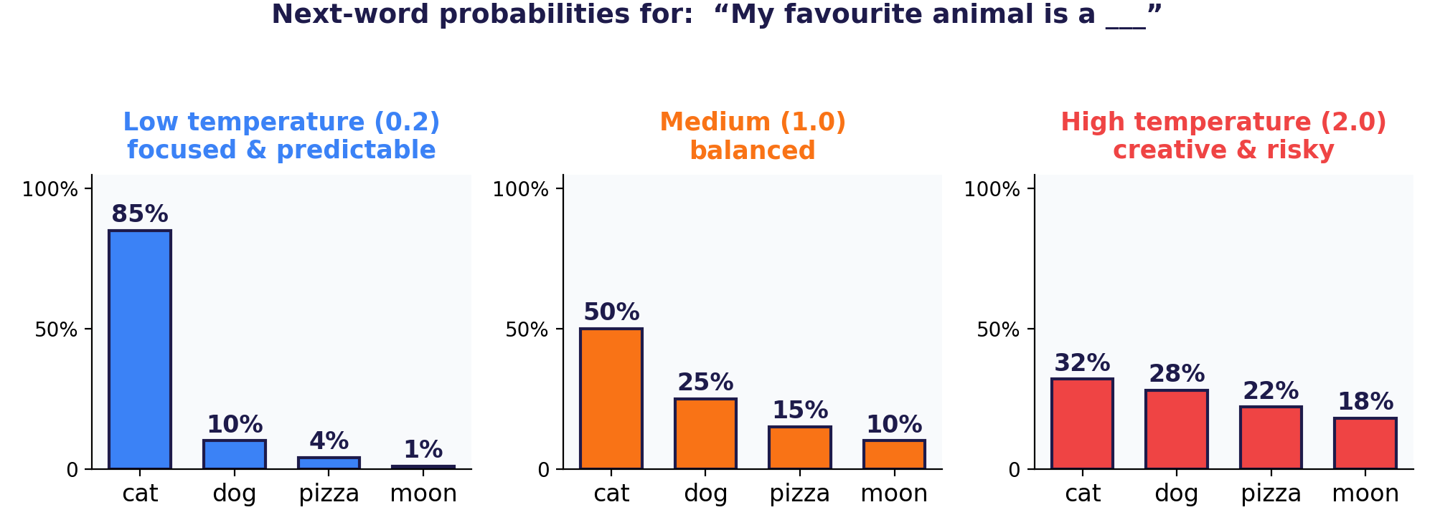
Low (about 0.2) | Medium (about 1.0) | High (about 2.0)
Top choice dominates. Safe, repeatable, can be dull. | A healthy mix of likely and less likely words. | Probabilities flatten. Creative, surprising, but riskier.
Best for: facts, maths, code | Best for: everyday chat | Best for: brainstorming, poems

Greedy vs sampling
Greedy decoding always takes the single most likely token. Sampling draws a token at random according to the probabilities, and temperature reshapes those probabilities first.

Extra control
Top-k and top-p sampling limit the draw to the most likely tokens, which avoids nonsense words while keeping variety.

ACTIVITY 3 | Temperature Lab
Name: ____________________ Class: __________ Date: __________ Score: ______
TASK A Shade the bars (each row = 5%) to show how temperature changes the probabilities.
T = 0.2 (low): blue 70%, clear 20%, grey 10%, falling 0% |  |  |  |  |  | T = 2.0 (high): blue 35%, clear 30%, grey 20%, falling 15%
75% |  |  |  |  |  | 75%
60% |  |  |  |  |  | 60%
45% |  |  |  |  |  | 45%
30% |  |  |  |  |  | 30%
15% |  |  |  |  |  | 15%
 | blue | clear | grey | falling |  |  | blue | clear | grey | falling

TASK B Choose a temperature (tick one) and explain why.
Job | Low | High | Why?
i) Solving a maths problem | ☐ | ☐
ii) Writing a fantasy poem | ☐ | ☐
iii) Answering a factual question | ☐ | ☐
TASK C Read the code, then answer.
import numpy as np

def sample(logits, temperature=1.0):
scaled = np.array(logits) / temperature
probs = np.exp(scaled - scaled.max())
probs /= probs.sum()
return np.random.choice(len(probs), p=probs)

logits = [2.0, 1.0, 0.1] # three candidate tokens

With temperature = 0.2 which token (0, 1 or 2) is chosen most often? What changes at 2.0?

CONCEPT 7 | How an LLM Is Built


Building an LLM is a five-step journey. The big idea: first learn general language from massive data, then teach the model to be helpful and safe.
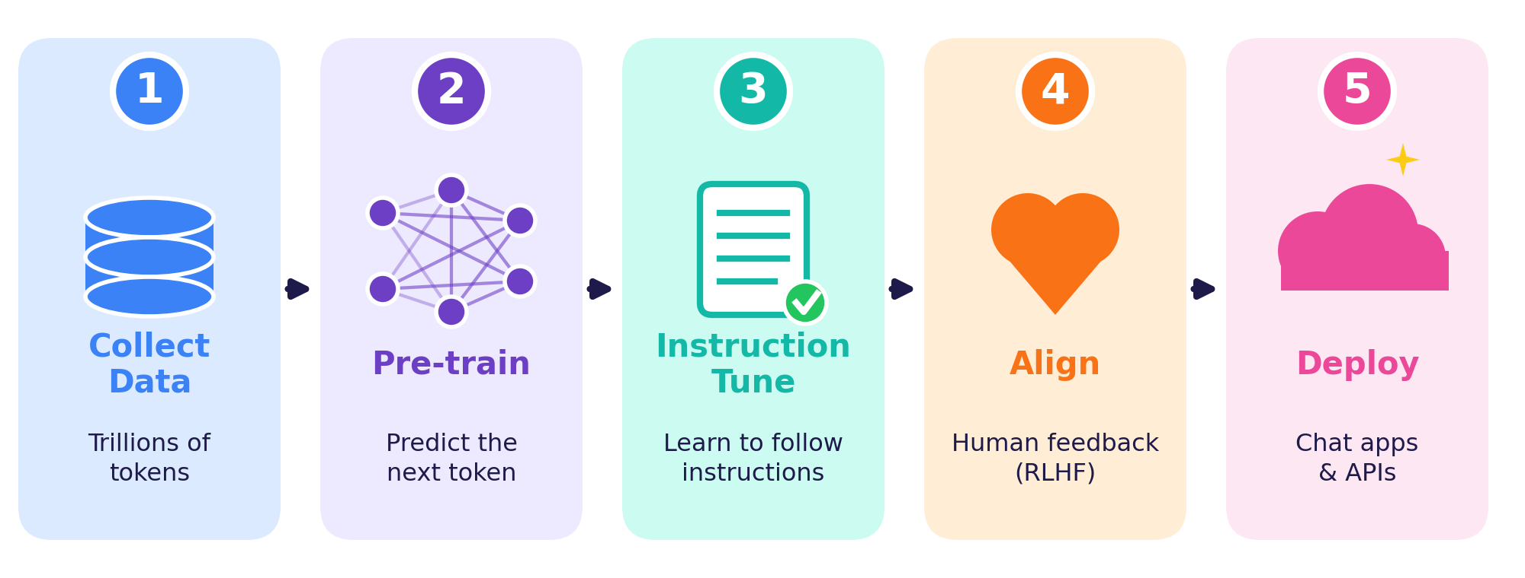
Stage | What happens | Everyday analogy
Pre-training | The model learns to predict the next token from trillions of tokens of text and code. | Reading a whole library
Instruction tuning | It trains on example questions paired with ideal answers, so it follows instructions. | Practising with a tutor
Alignment (RLHF) | Humans rank answers; the model learns to prefer helpful, honest, harmless ones. | Feedback on your essays
Deployment | The model is served through apps and APIs, adapted with prompts, RAG or tools. | Starting the job

Base model vs chat model
A base model only continues text. A chat model has been instruction-tuned and aligned, so it answers your request.

Scaling laws
Research shows quality improves predictably as parameters, data and compute grow together. Data quality and efficiency matter too, so smaller well-trained models can surprise us.

WORKSHEET 4 | Order the Pipeline
Name: ____________________ Class: __________ Date: __________ Score: ______
TASK A Number the steps of building an LLM from 1 (first) to 5 (last).
Step: ____ | Deploy through an app or an API
Step: ____ | Collect trillions of tokens of text and code
Step: ____ | Train with human feedback (RLHF)
Step: ____ | Pre-train by predicting the next token
Step: ____ | Instruction-tune with example questions and answers
TASK B Complete the sentences with the word bank.
WORD BANK: parameters • base model • RLHF • tokens • instruction tuning

1. The adjustable numbers a model learns during training are called ____________.
2. A model that only continues text and does not follow instructions is a ____________.
3. ____________ teaches a model using example questions and ideal answers.
4. Human rankings are used in ____________ to make answers safer and more helpful.
5. LLMs are trained on trillions of ____________ of text and code.
TASK C Compare a base model and a chat model by completing the table.
Feature | Base model | Chat model
Follows instructions?
Reply to “Write a poem about the sea”
Safety training (RLHF)?

CONCEPT 8 | Prompting and RAG


A prompt is the input you give a model. Clear prompts get better answers. Use the R-T-C-F recipe:
R Role | T Task | C Context | F Format
Who should the AI be? | What exactly must it do? | What background does it need? | How should the answer look?

Example of a strong prompt
“You are a friendly AI tutor (R). Explain self-attention (T) to a third-year engineering student who knows basic neural networks (C). Use three bullet points and one analogy (F).”

RAG: give the model a library card
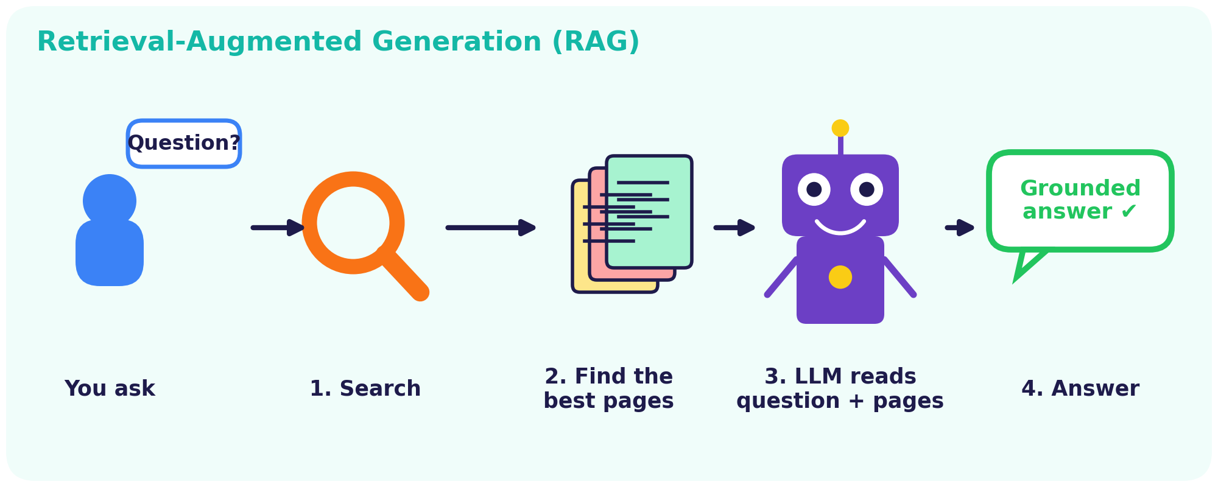
- Why? LLMs only know their training data and can be out of date or make things up.
- How? RAG searches trusted documents and adds the best pages to the prompt, so answers are grounded and can cite sources.
- More tools: Fine-tuning adapts a model to a field; agents let it use tools such as search or code.

ACTIVITY 4 | Prompt Makeover
Name: ____________________ Class: __________ Date: __________ Score: ______
TASK A These prompts are weak. Rewrite each one using R-T-C-F.
1. Weak: “Tell me about AI.”
2. Weak: “Write code.”
3. Weak: “Help with my essay.”
TASK B Build a prompt. Scenario: you want a 5-question quiz about GANs for your classmates.
R Role
T Task
C Context
F Format
TASK C Design a Campus Helper chatbot that uses RAG. List 3 documents it should search and 1 question it must answer.
Swap with a partner and rate their best prompt: ☆ ☆ ☆ ☆ ☆

CONCEPT 9 | Risks and Responsible AI


Generative AI is powerful but imperfect. Good engineers know its weaknesses and plan for them.
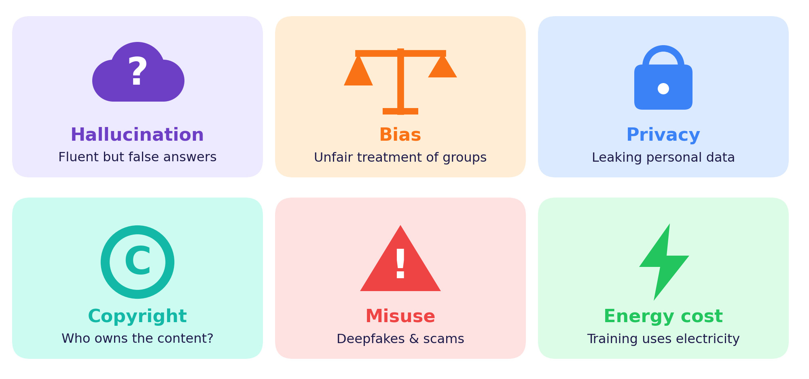
Risk | Example | What we can do
Hallucination | Invents a fake reference | Verify with trusted sources; use RAG
Bias | A hiring tool favours one group | Diverse data, audits, human review
Privacy | Confidential data pasted into a chatbot | Never share sensitive information
Copyright | Output resembles protected work | Check licences and credit sources
Misuse | Deepfake video or scam email | Label AI content; verify before sharing
Energy cost | Training uses lots of electricity | Efficient models, cleaner power

Student code of practice
- Treat AI output as a draft to check, not as the truth.
- Follow your institution’s academic-integrity rules and disclose AI help.
- Never enter confidential or personal information into public tools.
- Use AI to deepen your understanding, not to replace your thinking.

WORKSHEET 5 | Fact or Fib?
Name: ____________________ Class: __________ Date: __________ Score: ______
TASK A Hallucination hunt. Tick Fact or Fib, then say how you would check it.
# | Statement | Fact | Fib | How to check?
1 | The Transformer was introduced in the 2017 paper “Attention Is All You Need”. | ☐ | ☐
2 | A GAN has a generator and a discriminator. | ☐ | ☐
3 | A fluent answer from an LLM is always correct. | ☐ | ☐
4 | Temperature 0 makes an LLM produce wildly random text. | ☐ | ☐
5 | RAG lets a model use outside documents when it answers. | ☐ | ☐
6 | The context window is the number of layers in a model. | ☐ | ☐
TASK B Name the main risk in each scenario: Bias, Privacy, Hallucination or Misuse.
Scenario | Risk
1) A chatbot cites a journal article that does not exist.
2) A hiring tool keeps rejecting one group of applicants.
3) A student pastes confidential company data into a public chatbot.
4) A fake video of a leader is shared to spread panic.
TASK C My AI Pledge. Write three rules you will follow when using AI for study.
Signature: ______________________

PUZZLE | AI Word Search
Name: ____________________ Class: __________ Date: __________ Score: ______
Find all 12 words. They run across, down or diagonally (top-left to bottom-right). Tick each word when you find it.
Q | D | I | F | F | U | S | I | O | N | X | K | N | X | J
B | V | T | G | E | N | E | R | A | T | I | V | E | J | D
A | K | R | H | A | S | F | W | V | Y | T | H | J | T | P
U | I | A | A | L | I | G | N | M | E | N | T | Y | Z | F
K | H | N | L | X | Y | H | I | C | Y | V | H | H | E | M
E | G | S | L | M | J | A | T | T | E | N | T | I | O | N
M | A | F | U | T | E | M | P | E | R | A | T | U | R | E
B | N | O | C | K | L | G | V | N | K | J | E | Q | S | P
E | Y | R | I | X | N | D | C | O | N | T | E | X | T | O
D | F | M | N | C | Y | B | L | F | X | D | C | X | T | K
D | L | E | A | V | Q | M | T | T | L | Q | N | S | L | Q
I | K | R | T | T | Y | U | L | T | S | T | O | K | E | N
N | S | A | I | P | F | Q | X | J | R | B | K | I | B | H
G | V | P | O | R | K | W | Z | H | J | N | Y | T | K | B
H | M | S | N | V | P | R | O | M | P | T | X | Y | S | E

☐ HALLUCINATION | ☐ TRANSFORMER | ☐ TEMPERATURE | ☐ EMBEDDING
☐ DIFFUSION | ☐ ATTENTION | ☐ GENERATIVE | ☐ ALIGNMENT
☐ CONTEXT | ☐ PROMPT | ☐ TOKEN | ☐ GAN

Riddles. Write the answer.
a) I chop sentences into little pieces for the model. ____________
b) I’m the list of numbers that gives a word its meaning. ____________
c) I control how random the next word is. ____________

QUIZ | Olympiad Challenge Quiz
Name: ____________________ Class: __________ Date: __________ Score: ______
Part A – Circle the best answer (1 mark each)
1. Which kind of model learns P(label | data)?
(A) Generative model (B) Autoregressive model (C) Discriminative model (D) Diffusion model
2. In a GAN, which network tries to tell real from fake?
(A) Generator (B) Encoder (C) Decoder (D) Discriminator
3. Which 2017 architecture powers modern LLMs?
(A) LSTM (B) Transformer (C) CNN (D) Perceptron
4. Raising the temperature makes the output…
(A) more random and varied (B) more deterministic (C) shorter (D) identical every time
5. A token is…
(A) a whole sentence (B) an image pixel (C) a chunk of text such as a word or sub-word (D) a GPU core
6. What does RAG add to an LLM?
(A) A bigger GPU (B) Retrieved external documents (C) Random noise (D) A new alphabet
7. Which stage teaches a model to follow instructions?
(A) Tokenization (B) Inference only (C) Embedding lookup (D) Instruction tuning
8. Diffusion models generate by…
(A) predicting the next word (B) removing noise step by step (C) classifying labels (D) compressing data only
9. A confident but false model output is called…
(A) alignment (B) an embedding (C) a hallucination (D) attention
10. Self-attention lets each token…
(A) ignore all others (B) delete other tokens (C) turn into an image (D) weigh how relevant other tokens are
Part B – Short answers (3 marks each)
11. In “the trophy didn’t fit in the suitcase because it was too big”, what does “it” refer to? How would the meaning change if the word was “small”?
12. Give two ways to reduce hallucinations in an LLM-based tool.

Total score: ______ / 16 Grade / Stars: ☆ ☆ ☆ ☆ ☆

ANSWERS | Answer Key

p4 Worksheet 1 | A: 1 D, 2 G, 3 D, 4 G, 5 D, 6 G, 7 D, 8 G, 9 D, 10 G (D = discriminative, G = generative). B, C: answers will vary.
p6 Activity 1 | A: 1 ELIZA, 2 Word2Vec, 3 Transformer, 4 GPT-3, 5 Goodfellow, 6 Diffusion. B: A=4, B=2, C=3, D=1, E=5.
p8 Worksheet 2 | A: 1-D, 2-B, 3-A, 4-C. B: a) Autoregressive, b) Diffusion, c) VAE, d) GAN. C: 1 F, 2 T, 3 T. D: the generator keeps producing only a few similar outputs that fool the discriminator.
p10 Activity 2 | A: sample splits: un|happi|ness (3), play|ing (2), Gener|ative (2), token|ization (2), AI|-|powered (3); real tokenizers vary. B: a) about 3,000 words, b) about 2,000 tokens. C: king–queen, apple–banana and car–truck pairs should be close.
p12 Worksheet 3 | A: 1 trophy, 2 suitcase, 3 professor, 4 laptop. B: cat 5, hungry 2–3, fish 1–2, others 0–1 (answers may vary). C, D: attention links words by context; parallel reading is faster to train.
p14 Activity 3 | A: low = 14, 4, 2, 0 rows; high = 7, 6, 4, 3 rows. B: i) low, ii) high, iii) low. C: token 0 at 0.2; at 2.0 the choices become more varied.
p16 Worksheet 4 | A: Deploy 5, Collect 1, RLHF 4, Pre-train 2, Instruction-tune 3. B: 1 parameters, 2 base model, 3 instruction tuning, 4 RLHF, 5 tokens. C: base model: not reliably, may continue the prompt, little safety training; chat model: yes, writes the poem, has RLHF safety training.
p20 Worksheet 5 | A: 1 Fact, 2 Fact, 3 Fib, 4 Fib, 5 Fact, 6 Fib. B: 1 Hallucination, 2 Bias, 3 Privacy, 4 Misuse.
p21 Puzzle | Riddles: a) token, b) embedding, c) temperature. Word positions: HALLUCINATION (r3, c4, down); TRANSFORMER (r2, c3, down); TEMPERATURE (r7, c5, across); EMBEDDING (r6, c1, down); DIFFUSION (r1, c2, across); ATTENTION (r6, c7, across); GENERATIVE (r2, c4, across); ALIGNMENT (r4, c4, across); CONTEXT (r9, c8, across); PROMPT (r15, c6, across); TOKEN (r12, c11, across); GAN (r6, c2, down).
p22 Quiz | Part A: 1 C, 2 D, 3 B, 4 A, 5 C, 6 B, 7 D, 8 B, 9 C, 10 D. Part B: 11 “it” = trophy (too big); with “small” it = suitcase, so attention shifts. 12 e.g. RAG, citing and checking sources, human review, lower temperature.

Teacher note
Open-ended tasks (sketches, rewrites, predictions) reward clear reasoning rather than one correct answer. Encourage students to compare answers in pairs.

